Vyomex Drone Technology

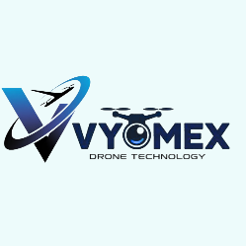 logo mathiru background remove

Main Heading - “The Sky Is No Longer the Limit.”
Small Heading - Drone Technology • AI • Robotics • Industrial Innovation
ELATHAIUM KILA REMOVE PANIRU -PROJECT COMPLETED ETC..
🚀 About Us – Vyomex Drone Technology
“கல்வி தரும் இறக்கைகள், வானம் தரும் இலக்கு.”
(Education gives wings, the sky gives a goal.)
Vyomex Drone Technology is an emerging leader in the field of drone innovation, delivering intelligent solutions across industries such as infrastructure, agriculture, education, and industrial applications. With a strong focus on practical implementation and continuous innovation, we aim to transform how drone technology is used in real-world environments.
Founded by a team of passionate aeronautical engineers, Vyomex is committed to building the future through skill-based drone education and advanced aerial solutions. Our approach combines technical knowledge with hands-on experience, ensuring that every learner gains real-world exposure.
🚀 Our Services
Drone Education
Seminars, workshops & internship programs
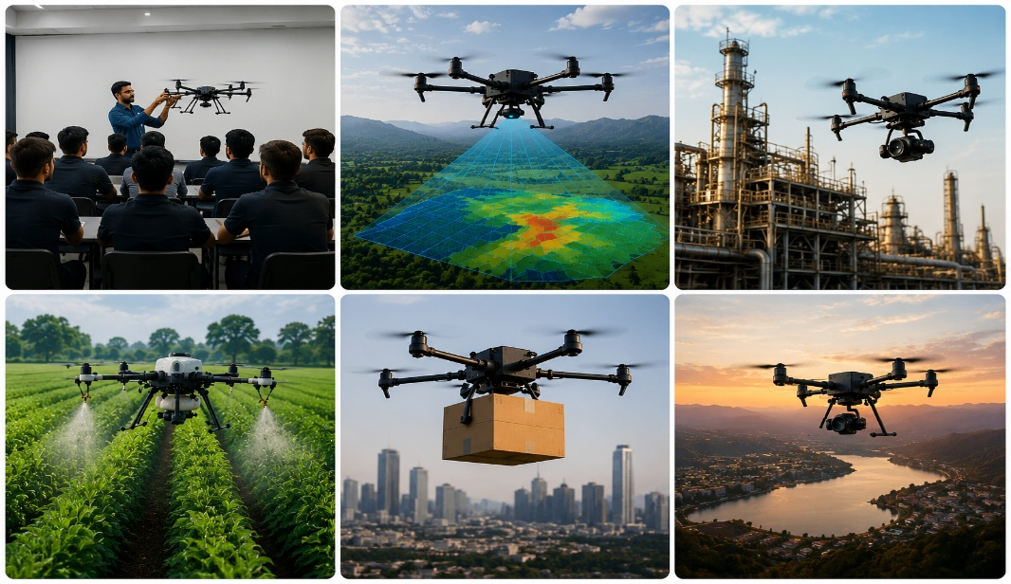
Drone Inspection
Safe and accurate infrastructure analysis
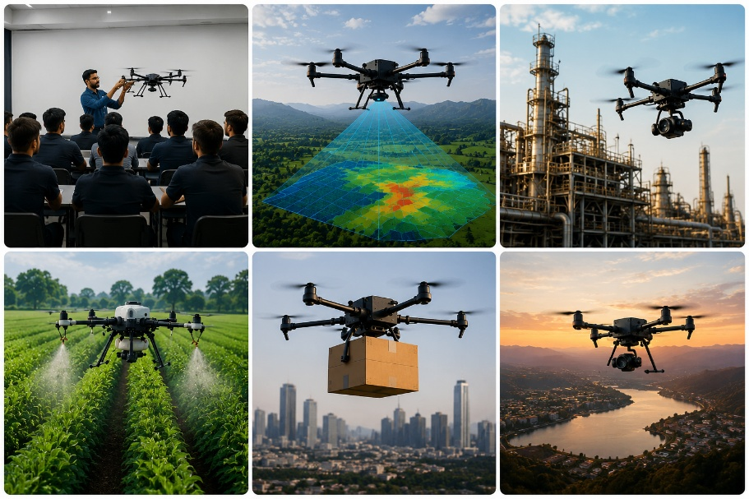
Aerial Mapping
Surveying and 3D modeling solutions
Agriculture Drones
Smart crop monitoring & spraying
Aerial Shoots
Events, promotions & cinematic visuals
Custom Solutions
Tailor-made drone technology
⚙️ Why Choose Us
🎓 Expert Team & Proven Impact
Our team of skilled professionals and aeronautical engineers has successfully trained 20,000+ students through seminars, workshops, and hands-on programs, building a strong foundation in drone technology.
Advanced Tech
High-precision UAV systems
Fast Execution
Quick & efficient delivery
Safe Operations
Reliable & secure workflow
Accurate Data
Insights & detailed reports
Client Focus
Customized solutions
⚙️ How We Work
Understand
Analyzing project requirements
Plan
Creating the best execution strategy
Execute
Performing precise drone operations
Analyze
Processing data & generating insights
Deliver
Providing accurate final outputs & support

- 📊 Our Impact
- 🎓 5,000+ Students Trained
- Our faculties and experts have successfully trained over 5,000 students through hands-on drone workshops, seminars, and internship programs.

- 🚀 75+ Workshops Conducted
- Interactive drone workshops and technical sessions conducted across schools, colleges, and institutions.

- 🏫 Institutional Collaborations
- Partnering with educational institutions to promote innovation and practical learning in drone technology.

- ⚡ Industry Exposure Programs
- Providing real-world exposure through industrial visits, live demonstrations, and practical UAV applications

Contact 7200198877
Mail vyomexdronetech@gmail.com
